Microservices Architecture using ASP.NET Core Web API
Hands-on: Microservices – JWT

Aim: To implement JWT (JSON Web Token) authentication and authorization in an ASP.NET Core Web API application by generating JWT tokens, securing API endpoints using the [Authorize] attribute, implementing role-based authorization, and validating JWT token expiration.
Theory:
JWT (JSON Web Token): JWT is a secure and compact token used to authenticate users and authorize access to protected resources. It contains user information in an encrypted format and is digitally signed to prevent tampering.
Authentication and Authorization: Authentication verifies the identity of a user, while authorization determines whether the authenticated user has permission to access a particular resource.
Bearer Token: A Bearer token is a JWT sent in the HTTP Authorization header to access protected API endpoints.
Authorize Attribute: The [Authorize] attribute restricts API access to authenticated users only.

Procedure:
- Created an ASP.NET Core Web API project using .NET 8.
- Installed the Microsoft.AspNetCore.Authentication.JwtBearer NuGet package.
- Configured JWT settings in appsettings.json.
- Configured JWT authentication and Swagger security in Program.cs.
- Created the User and LoginModel classes.
- Implemented AuthController to authenticate users and generate JWT tokens.
- Created SecureController and secured its endpoint using the [Authorize] attribute.
- Implemented role-based authorization using [Authorize(Roles = "Admin")].
- Configured JWT token expiration and verified that expired tokens return 401 Unauthorized.
- Tested all APIs using Swagger:
- Generated JWT token.
- Accessed protected API with a valid token.
- Verified role-based authorization.
- Verified token expiration behavior.

SecureController.cs:
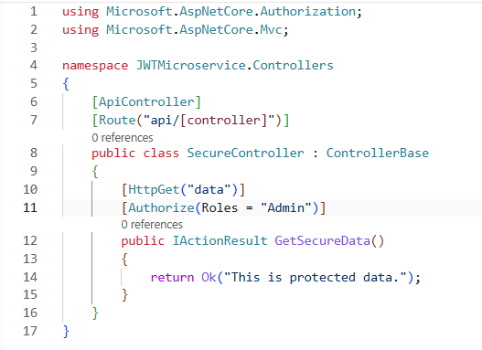
Appsettings.json:
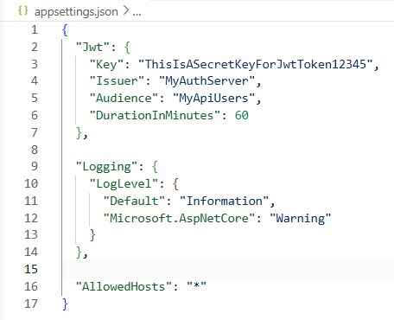

AuthController.cs:
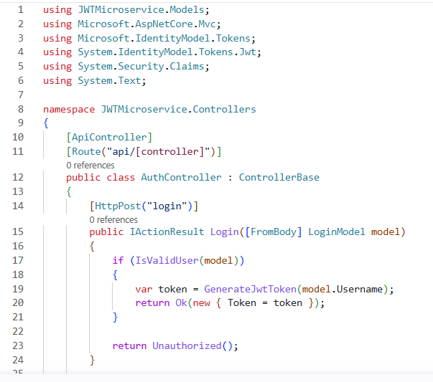
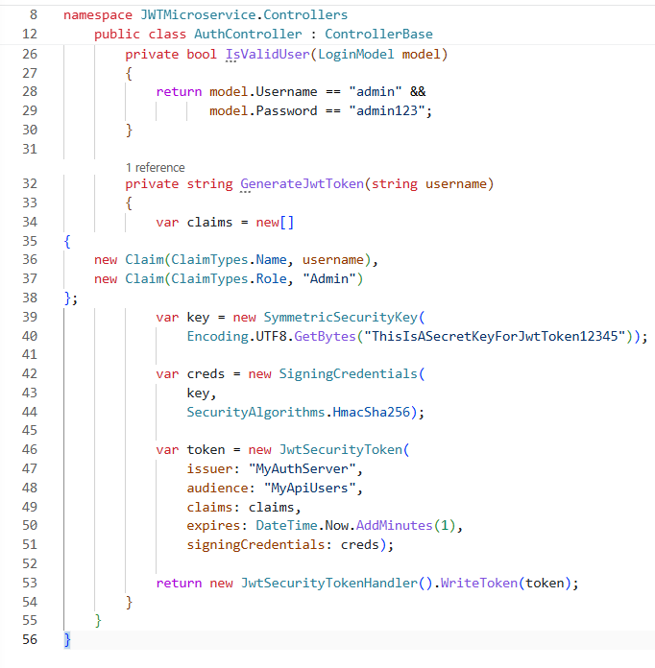

Output:
POST /api/Auth/login
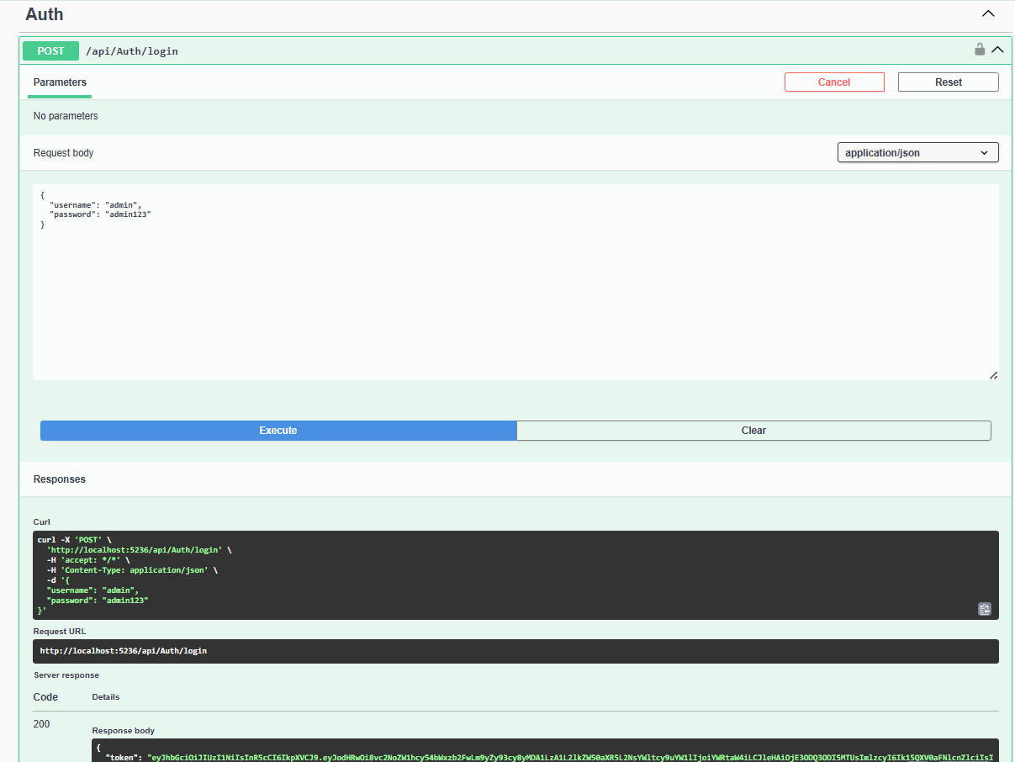
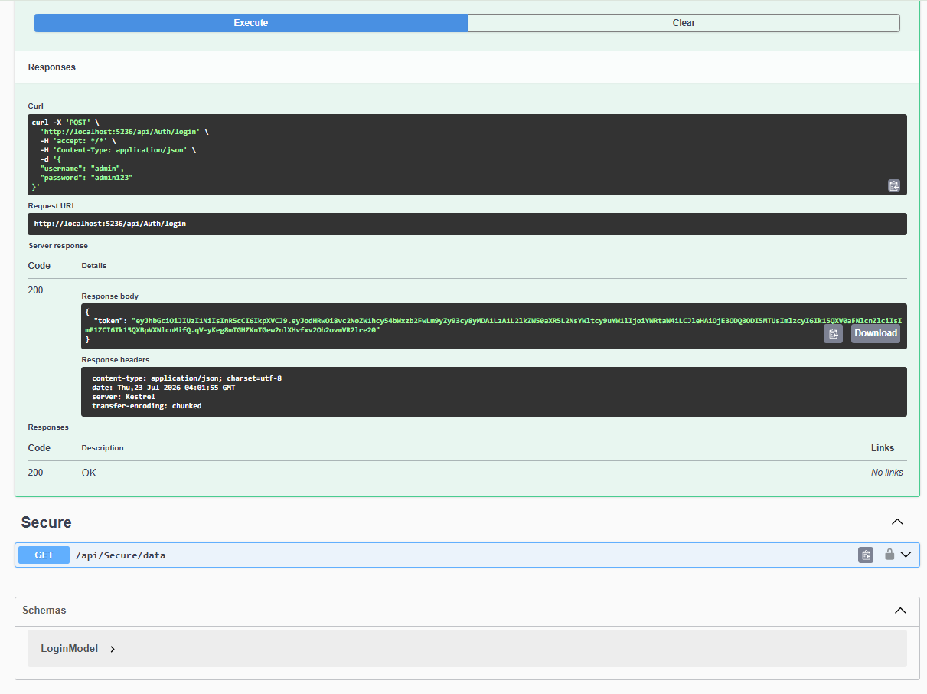
GET /api/Secure/data → 200 OK
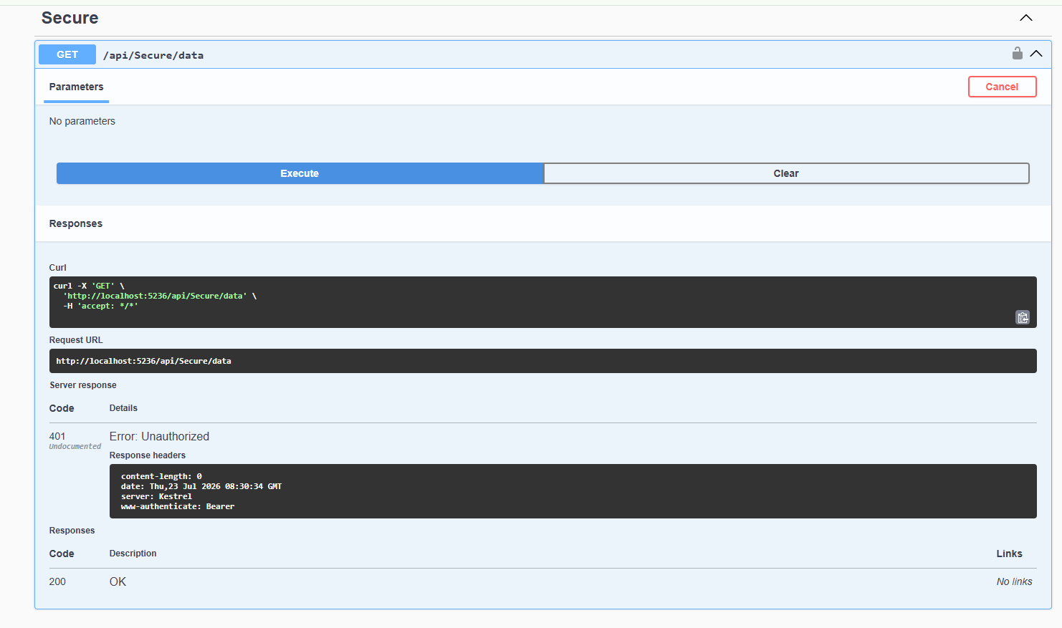
GET /api/Secure/data after token expiry → 401 Unauthorized
